An atoms-to-mesoscale approach to ice-vapor surface dynamics with a quasi-liquid interface

Steven Neshyba¹, Spencer Racca-Gwozdzik¹, Ella Slattery¹, and Ezra Thill¹

¹University of Puget Sound, Tacoma Washington USA

Abstract
We explore the hypothesis that a key factor in determining the dynamics and morphology of faceted ice-vapor surfaces is the quasi-liquid layer that forms at this interface at temperatures above $240 K$. We do so by modeling the ice surface as a system of reaction-diffusion equations in which the time scales of quasi-liquid freezing and melting, horizontal diffusion, and exchanges with the vapor phase are made explicit. Model parameterizations integrated with vapor field around growing and ablating ice crystals. Our results support a differential diffusive slowdown mechanism that compensates for inhomogeneities in the concentration of vapor pressure at the ice-vapor interface, which appears mathematically as a limit cycle in the thickness of the quasiliquid layer.

Plain Language Summary
This is a mathematical and computational exploration of the texture of ice surfaces on a microscopic scale. The main hypothesis is that this texture is governed by the behavior of a thin layer of water, intermediate between ice and liquid, that is known to form at the ice-air interface. We carry out this exploration by constructing a set of mathematical relationships that, when solved on a computer, reveal how parts of this quasi-liquid layer migrate to other regions of the ice surface, freeze, or evaporate into the air. The form and parameters of these equations are informed by insights from simulations of the vapor concentrations surrounding the ice crystal.

- Introduction
Ice crystals that make up cirrus clouds modulate Earth’s climate by reflecting or scattering sunlight before it reaches Earth’s surface, but the extent to which they do that depends on the morphology of those crystals. Although hexagonal prisms dominate, there is a great deal of variation: long and thin hexagonal needles, short and wide plates, indentations and hollowing, and even dendritic forms, like snowflakes. Moreover, facets can be rough on a scale that matters to light of comparable wavelength (Järvinen et al. 2023) …. Because of this variability, integrating morphologies into climate models remains a formidable task, and contributes to the large uncertainties in climate change prediction by IPCC.

All this points to a need for better models of ice surface morphology and dynamics. Numerous approaches have been developed, of which Harrington and Pokrifka (2021) provide an excellent review … Molecular Dynamics studies have contributed greatly to this effort (see, e.g., (Llombart, Noya, and MacDowell 2020)). Here we focus on two approaches in particular, Classical Nucleation Theory and Continuum theory, because they are particularly relevant to the work presented here.

Classical Nucleation Theory. CNT’s atomistic view of the process of crystal growth goes along the following lines: when a gas-phase molecule (e.g., a water molecule) encounters a crystalline surface, it initially becomes attached to that surface as an “admolecule.” Not yet part of the crystal’s lattice, this admolecule diffuses across the surface until it meets one of two fates: either it fills an unoccupied position in the crystal lattice, or else it returns to the gas phase. New layer formation is governed by a 2D nucleation process in which the step free energy plays a central role (Kuroda and Lacmann 1982).

CNT has long framed how we think about ice crystal growth from the vapor phase, but it suffers from two drawbacks. First, it offers little guidance when it comes to describing the behavior of crystals placed in a vapor field that is inhomogeneous on a mesoscopic scale. To be specific, when a growing faceted ice crystal is situated in a supersaturated vapor field, the expectation is that the surrounding water vapor concentration will be drawn down in such a way that parts of the crystal that protrude out more into the surrounding vapor (i.e., crystal corners) will experience persistently higher vapor pressures than facet centers. CNT predicts that this would result in faster growth at those corners, leading ultimately to dendritic forms (e.g., snowflakes). However, under typical cirrus cloud conditions, it is known that hexagonal prisms resist that tendency, despite those inhomogeneities. Classical nucleation theory has no satisfactory explanation for the persistence of hexagonal prismatic habit in the presence of inhomogeneities in the overlying vapor. (However, see Jayaprakash et al (1983)).

A second shortcoming of CNT concerned the presence of a quasi-liquid layer on the surface. This is particular to ice: when the temperature of ice rises above $240 K$, both experiment and theoretical studies have shown that the ice/air interface is covered by a quasi-liquid layer (QLL); molecular dynamics studies have shown that water molecules striking the surface are thermalized by the QLL efficiently and quickly (on a picosecond time scale) (Neshyba et al. 2009). The presence of a QLL does not preclude crystalline layering: recent experimental work has shown that steps and ledges may form underneath the QLL, i.e., at the interface between the QLL and the underlying ice (Murata, Nagashima, and Sazaki 2019). It is clear that CNT is ill-equipped to describe such structures.

Continuum approaches. A Quasi-liquid-continuum model, here referred to as QLC-1, was presented by some of the authors in (Neshyba et al. 2016, henceforth N2016) as a way to address these shortcomings. Key components of the theory are variables $N_{tot}$ and $N_{QLL}$, representing the total thickness of the ice surface, and its quasi-liquid part, respectively (see Fig. 1). QLC-1 prescribes the time evolution of these variables by a pair of reaction-diffusion equations, taking into account exchange of QLL molecules with the vapor phase (deposition and ablation), diffusion of QLL molecules across the ice surface, and interconversion of QLL molecules to/from the underlying ice.

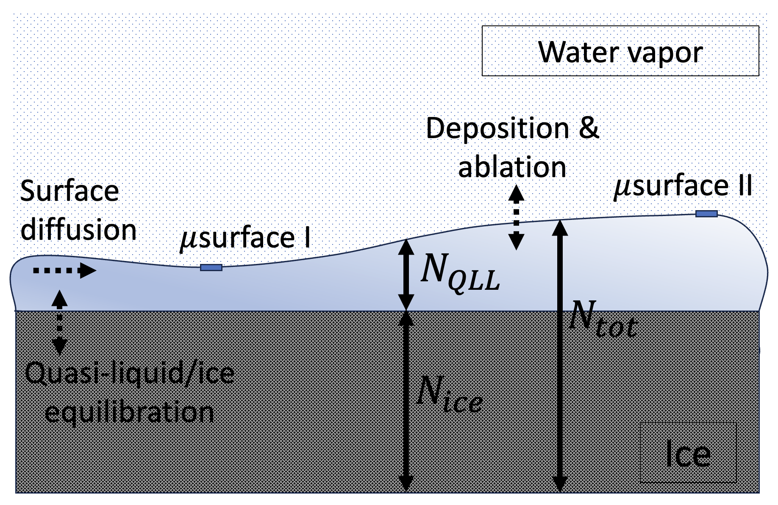
Figure 1. Visual representation of mesoscale variables $N_{tot}$, $N_{ice}$, and $N_{QLL}$, and processes affecting them, in QLC-1 (as well as the present revision, QLC-2) model.

The main insight afforded by QLC-1 is the following: through the interplay of quasiliquid volatility and thickness, an ice surface evolves spontaneously in a way that inhomogeneities in the rate of deposition from the vapor are compensated for by changes in the surface. In other words, QLC-1 provides a mechanism for faceted crystal growth in the presence of a QLL. N2016 provides a quantitative description of this mechanism, but for convenience the main features are presented in an Appendix.

QLC-1 also has significant limitations. A structural limitation of is that the time scale of the interconversion of quasi-liquid and ice relative to the other two processes (deposition/ablation and quasi-liquid/ice equilibration shown in Fig. 1) is fixed. In real crystal facets, these time scales could vary from facet to facet, or as a function of temperature and vapor pressure, and therefore should therefore be adjustable quantities of the theory. A second shortcoming is that, as presented in N2016, inhomogeneities in the overlying vapor field used in simulations were limited to growth conditions, and of a form that relied on untested assumptions about the structure of that inhomogeneity.

Our goal in the present communication is to generalize these insights from QLC-1 to a more diverse set of overlying vapor fields (including, e.g., ablation conditions), and to narrow the number and range of parameters through the application of physical constraints and non-dimensionalization techniques. We also address the above structural limitation in QLC-1 just mentioned, having to do with the time scale of quasi-liquid/ice equilibration dynamics. These are described in the next section.

- QLC-2/VP theory

2.1 Vapor Field (VF) theory
A key feature of the revised theory presented here is that the overlying water vapor is obtained from simulation of the water vapor partial pressure, $P_{vap}\left(x,y\right)$, within a space surrounding an idealized, two-dimensional crystal. This is accomplished by integrating the two-dimensional diffusion equation

$\frac{∂P_{vap}}{∂t}=D_{vap}∇^{2}P_{vap}$ (1)

where $D_{vap}$ is the diffusion coefficient of water vapor through air, computed by

$D_{vap}=D_{vap}^{o} {\left(\frac{P_{amb}}{1 atm}\right)}^{-1}{\left(\frac{T_{amb}}{273 K}\right)}^{m_{D}}$ (2)

(see Air-Diffusion Coefficients of Gases in Excess of Air).

Equation 1 is solved subject to Neumann and Dirichlet boundary conditions. The latter represents a constant, far-field vapor concentration at the outside boundary of the simulation space, $σ_{I,∞}$. Neumann conditions represent changes in water vapor at the crystal surface due to crystal growth or ablation,

$- g_{ice}×ρ_{ice}×\frac{RT}{M_{H_{2}O}}$ (3)

where $g_{ice}$ is the growth rate of the ice surface, $ρ_{ice}$ is the mass density of ice, and $M_{H_{2}O}$ is the molar mass of water. The desired result is what we will call the imposed surface supersaturation, $σ_{I}\left(x\right)$, for those conditions, defined relative to $μ$surface I of Fig. 1.

2.2 QLC-2 theory.
The QLC-2 equations of motion are

$\frac{{∂N}_{tot}}{∂t}=D_{QLL}∇_{x}^{2}N_{QLL}+ν_{kin}σ_{m}({x,N}_{QLL})$ (4a)

$\frac{{∂N}_{QLL}}{∂t}=\frac{{∂N}_{tot}}{∂t}-\left(N_{QLL}-N_{QLL}^{eq}(N_{tot})\right)/t_{eq}$ (4b)

and have the following properties:

- The term $\left(N_{QLL}-N_{QLL}^{eq}(N_{tot})\right)/t_{eq}$ in Eq. 4b is the primary departure of QLC-2 from QLC-1. The denominator, $t_{eq}$, is a first-order relaxation constant describing the time scale of quasi-liquid/ice equilibration shown in Fig. 1.

- The operator $D_{QLL}∇_{x}^{2}$ represents surface diffusion of the QLL; it operates on $N_{QLL}$, rather than $N_{tot}$, to reflect the idea that the underlying ice is immobile on time scales considered here. The diffusion coefficient will be assumed here to depend on temperature according to

$D_{QLL}=D_{QLL}^{o}exp\left(-\frac{E_{a}}{R}\left(\frac{1}{T}-\frac{1}{T_{o}}\right)\right)$ (5)

- $ν_{kin}$ is the rate at which vapor-phase water molecules strike the quasi-liquid. It is assumed that these stick with 100% efficiency, and thermalize on a picosecond time scale (i.e., instantaneously within the time scale of QLC-2 simulations). It can be obtained from the temperature according to the Hertz-Knudsen formula,

$ν_{kin}=P_{vap}^{eq}(T)×{\left(\frac{M_{H_{2}O}}{2πRT}\right)}^{1/2}$ (6)

where $P_{vap}^{eq}(T)$ is water’s equilibrium vapor pressure, and $M_{H_{2}O}$ is its molar mass.

- $N_{QLL}^{eq}(N_{tot})$ prescribes the thickness of quasi-liquid when it is in equilibrium with the underlying ice,

$N_{QLL}^{eq}(N_{tot})=\overline{N}-N^{*}sin⁡(2πN_{tot})$ (7)

This formulation ensures that the QLL thickness varies continuously and periodically from the thin “$μ$surface I” (with thickness $\overline{N}-N^{*}$) to the thick “$μ$surface II” (with thickness $\overline{N}+N^{*}$). (Note the connection to work of (Benet et al. 2019, Eq. 8), that also shows a sinusoidal dependence.)

- The effective surface supersaturation, $σ_{m}$ in Eq. 4a, depends on the imposed surface supersaturation, $σ_{I}(x)$, obtained from VF simulations. QLC-2 theory employs a parabolic form as an approximation to the latter,

$σ_{I}\left(x\right)≈σ_{I,corner}×\left(c_{r}{\left(\frac{x}{L}\right)}^{2}+(1-c_{r})\right)$ (8)

where $c_{r}$ is a “center reduction”, the fractional reduction of supersaturation at facet centers relative to facet corners,

$c_{r}=1-\frac{σ_{I,middle}}{σ_{I,corner}}$ (9)

Negative values of $c_{r}$ are used to represent subsaturation conditions, when the ablating crystal produces higher water vapor concentration at facet centers, compared to facet corners.

Because $σ_{I}\left(x\right)$ is defined to be relative to $μ$surface I, we require a way to compute the effective surface supersaturation, $σ_{m}$, corresponding to other possible thickness of the QLL. Defining $σ^{o}$ to be a measure of the difference in volatility of $μ$surface I and $μ$surface II, we adopt the formula

$σ_{m}(x) =σ_{I}(x)-\left(\frac{N_{QLL}-\left(\overline{N}-N^{*}\right)}{2N^{*}}\right)σ^{o}$ (10)

In combination with Eq. 9, Eq. 10 ensures that $μ$surface I will have $σ_{m}(x) =σ_{I}(x)$, while $μ$surface II will have $σ_{m}\left(x\right)=σ_{I}\left(x\right)-σ^{o}$.

- Transformation of Eqs. 4a and 4b using constants $τ=\frac{t}{t_{eq}}$ and $χ=x/{\left(D_{QLL}t_{eq}\right)}^{1/2}$ results in the nondimensional form

$\frac{{∂N}_{tot}}{∂τ}=∇_{χ}^{2}N_{QLL}+ω_{kin}σ_{m}({χ,N}_{QLL})$ (11a)

$\frac{{∂N}_{QLL}}{∂τ}=\frac{{∂N}_{tot}}{∂τ}-\left(N_{QLL}-N_{QLL}^{eq}(N_{tot})\right)$ (11b)

where $ω_{kin}={t_{eq}ν}_{kin}$. The utility of this transformation is that it exposes a key redundancy in the parameterization, namely, that since $D_{QLL}$ and $t_{eq}$ appear only as a product, it is not necessary to explore dependence on those parameters separately.

- Methods and parameterizations
Integration methods. The vapor pressure equation of motion (Eq. 1) is integrated over time using Euler’s method. Parameters are given in the Appendix. The QLC-2 equations of motion are solved using a variety of methods … ODE … Runge-Kutta45 …

Surface diffusion parameterization. Parameters appearing in Eq. 5 … fit of diffusion data of (Price, Ide, and Arata 1999) the Arrhenius form … $D_{QLL}^{o}$ … with $E_{a}=22.8\frac{kJ}{mol}$, $T_{o}=273 K$. Di Prinzio et al (Di Prinzio et al. 2020) report a surface diffusion coefficient of $3×{10}^{-3}\frac{μm^{2}}{μs}$ at -5°C, which (using this value of $E_{a}$) corresponds to $D^{o}=…\frac{μm^{2}}{μs}$.

Surface supersaturation parameterization. For this purpose, we employ an iterative scheme involving vapor field simulations around a growing or ablating ice crystal, as follows: For a chosen growth rate, $g_{ice}$, a set of far-field supersaturation values ($σ_{I,∞}$) is specified. A vapor field calculation for each $σ_{I,∞}$ produces a corresponding $σ_{I}\left(x\right)$ profile, each of which is then given as input to a QLC-2 model run. The $σ_{I}\left(x\right)$ profile that yields a QLC-2 growth rate closest to $g_{ice}$ is identified as the winner.

Other parameters …
- $\overline{N}=1$ and $N^{*}=0.143$
- $σ^{o}=0.2$
- $Δ_{N}$ (the thickness of a single layer of ice) $=0.389 nm$, to approximate the thickness of a prismatic facet bilayer
- $L$ (the distance from facet center to corner) $=30 μm$
- $t_{eq}$ (the ice-QLL equilibration time constant) $=100 ns$
- $T$ (temperature) $=240 K$
- $g_{ice}$ (the growth/ablation rate of the crystal) $=1 μm/s$

- Results
Typical VP results are shown in Fig. 2 … Bergian and non-Bergian ….

(a) | (b)
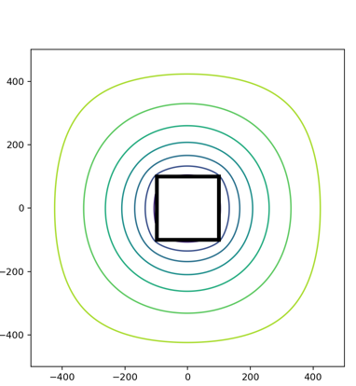 | 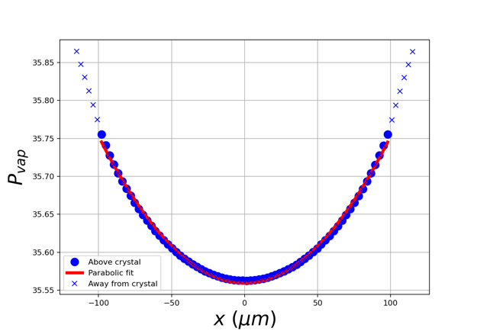
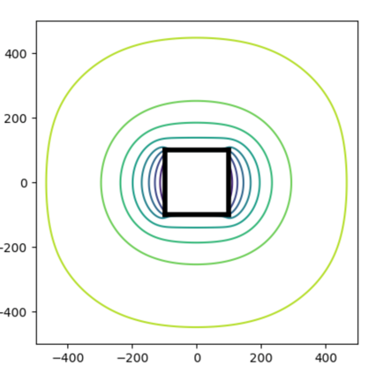 | 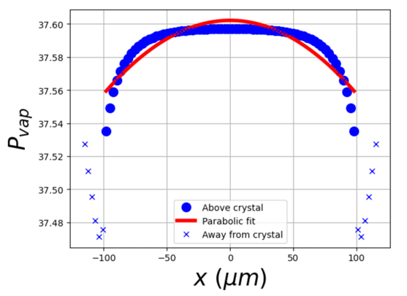
Figure 2. (a) Simulation of vapor partial pressures, $P_{vap}\left(x,y\right)$, in units $Pa$, around a growing ice crystal. The black-outlined box at the center indicates the surface of the crystal, in this case spanning $±100 μm$. Contours outside the crystal show values of $P_{vap}$ at steady state. Dirichlet conditions fix a partial pressure of $P_{H_{2}O,f}$ at the far-field distance of $±500 μm$, while Neumann conditions representing ice growth are imposed at the ice surface (see text). (b) $P_{vap}$ along the surface of the crystal.

A typical trajectory result is shown in Fig. 3, where it is seen that new layers have formed preferentially at facet corners (consistent with the Bergian parameterization of the overlying water vapor field).

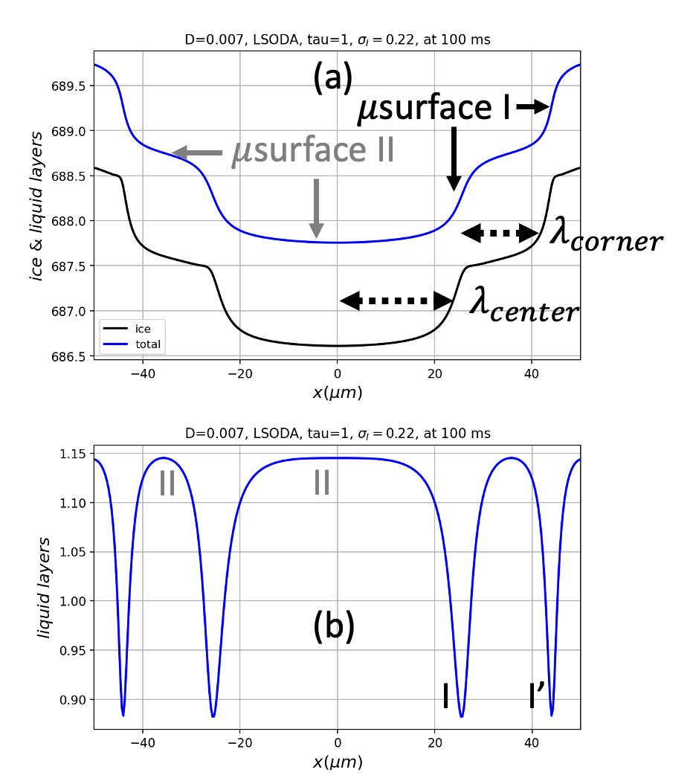
Figure 2. An ice surface covered by QLL, as simulated by QLM-2.

Figure 3 shows a modeled ice crystal surface subjected to three overlying vapor field profiles. All lead to steady-state solutions, but the shape of those solutions depends on the shape of the vapor profile, as follows:

- Scenario “V-shaped supersaturated vapor field”
A “V”-shaped supersaturated water vapor profile is the profile expected for growing, isolated cirrus ice crystals. After $\sim 100 ms$, an initially-flat ice surface converges to a steady state in which the surface is dominated by primarily $μ$surface I microstates, and is overall convex-shaped. Faceted growth is facilitated by smaller $λ$ at facet boundaries, which causes a reduction in the growth rate, compensating for the higher supersaturation at facet boundaries.

- Scenario “$Λ$-shaped supersaturated vapor field”
A “$Λ$”-shaped supersaturated water vapor profile concentration profile is not expected for growing, isolated cirrus ice crystals, but it is plausible in SEM experiments when other crystals are nearby. After $\sim 100 ms$, an initially-flat ice surface also converges, also to a steady state in which the surface is dominated by primarily $μ$surface I microstates, but in this case the overall shape is concave. Faceted growth is facilitated by smaller $λ$ at facet center, which causes a reduction in the growth rate, compensating for the higher supersaturation at facet center.

- Scenario “$Λ$-shaped subsaturated vapor field”
A “$Λ$”-shaped supersaturated water vapor profile concentration profile is expected for ablating isolated cirrus ice crystals. After $\sim 100 ms$, an initially-flat ice surface converges to a steady state in which the surface is dominated by primarily $μ$surface II microstates, and is overall concave-shaped. Faceted ablation is facilitated by smaller $λ$ at facet boundaries, which causes a reduction in the ablation rate, compensating for the more extreme subsaturation at facet boundaries.

V-shaped supersaturated vapor field | $Λ$-shaped supersaturated vapor field | $Λ$-shaped subsaturated vapor field
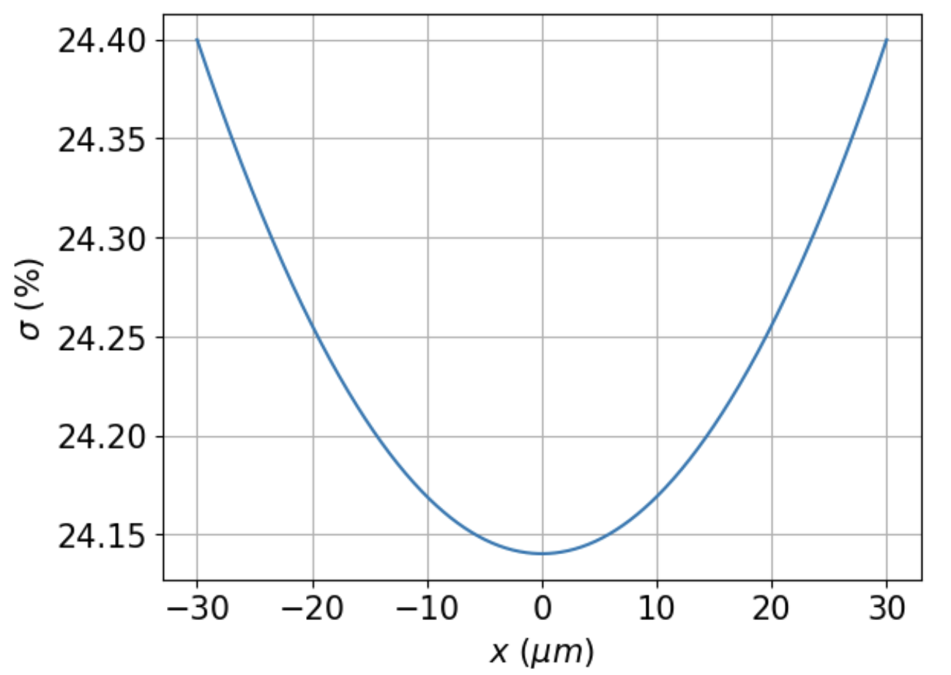 | 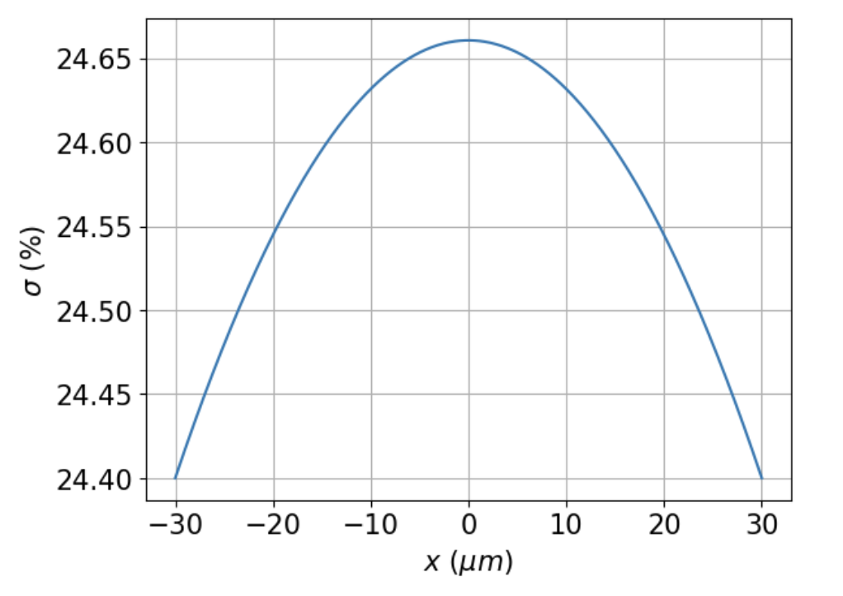 | 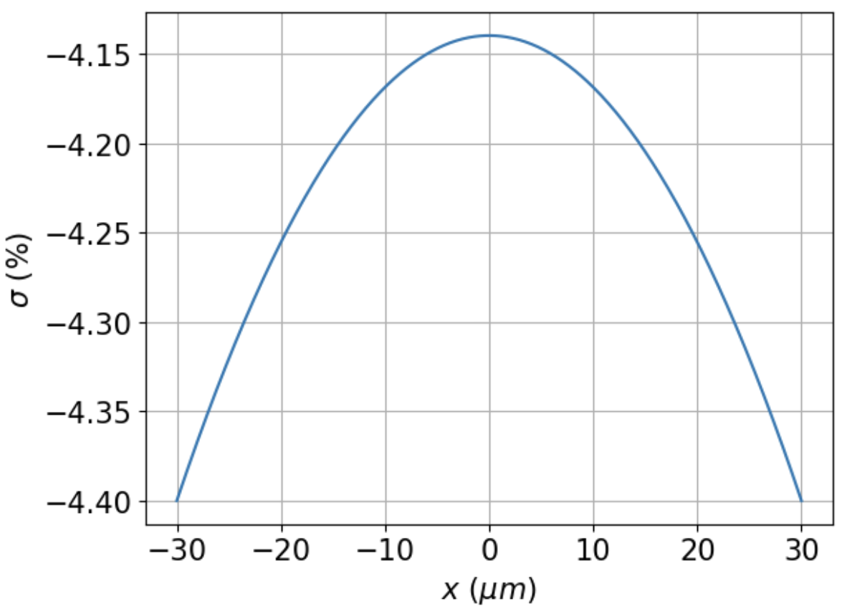
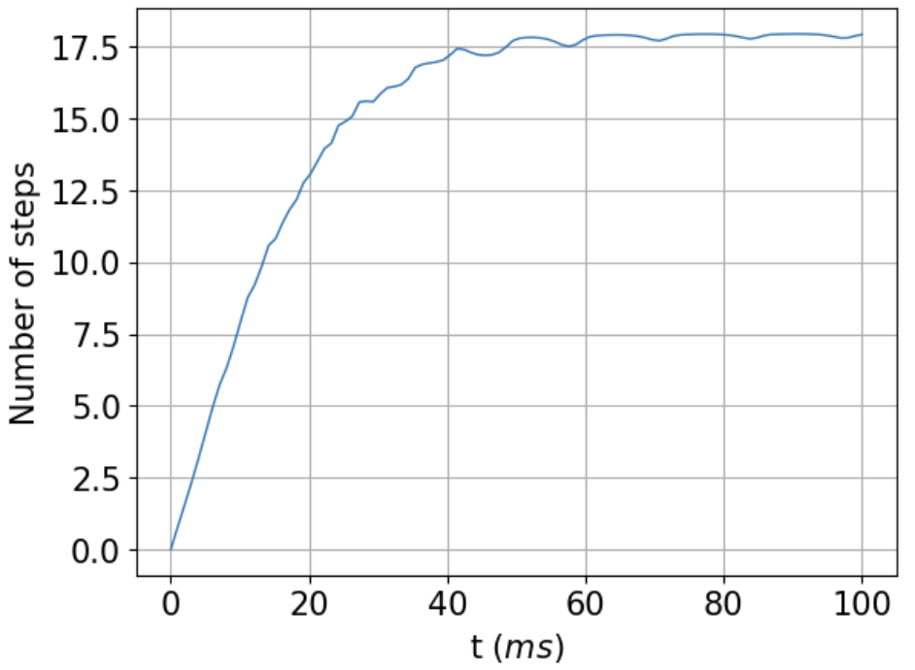 | 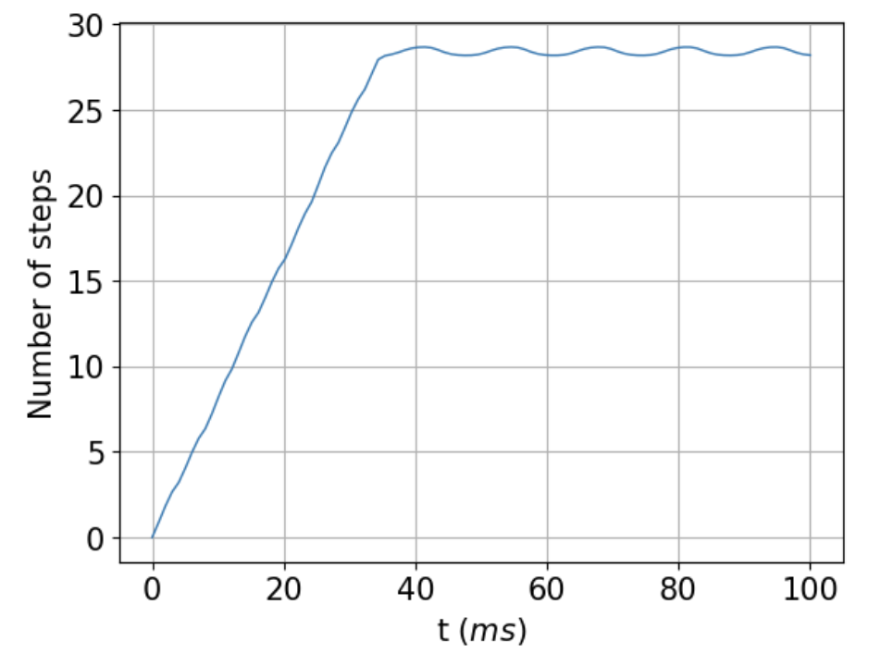 | 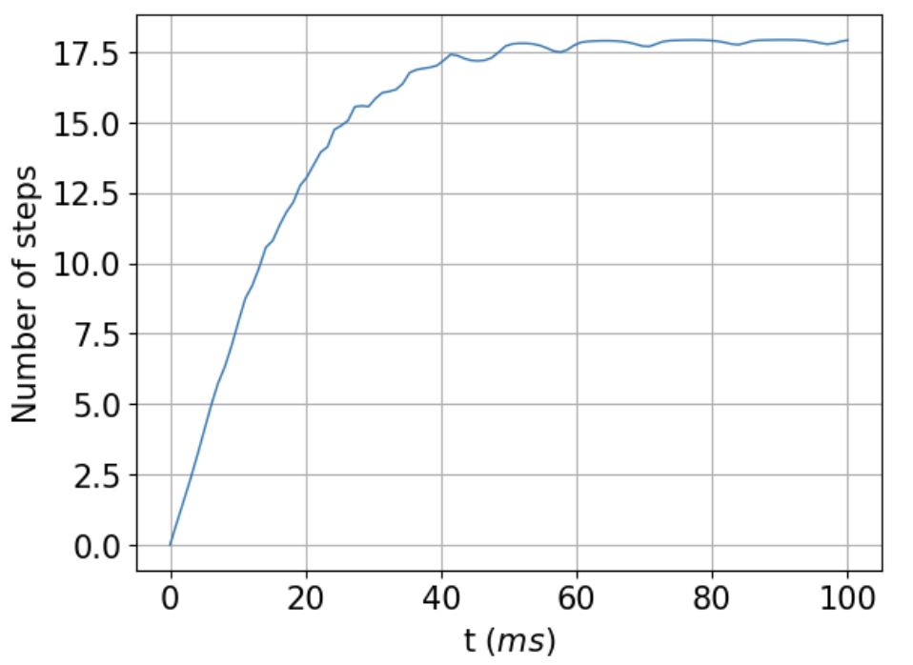
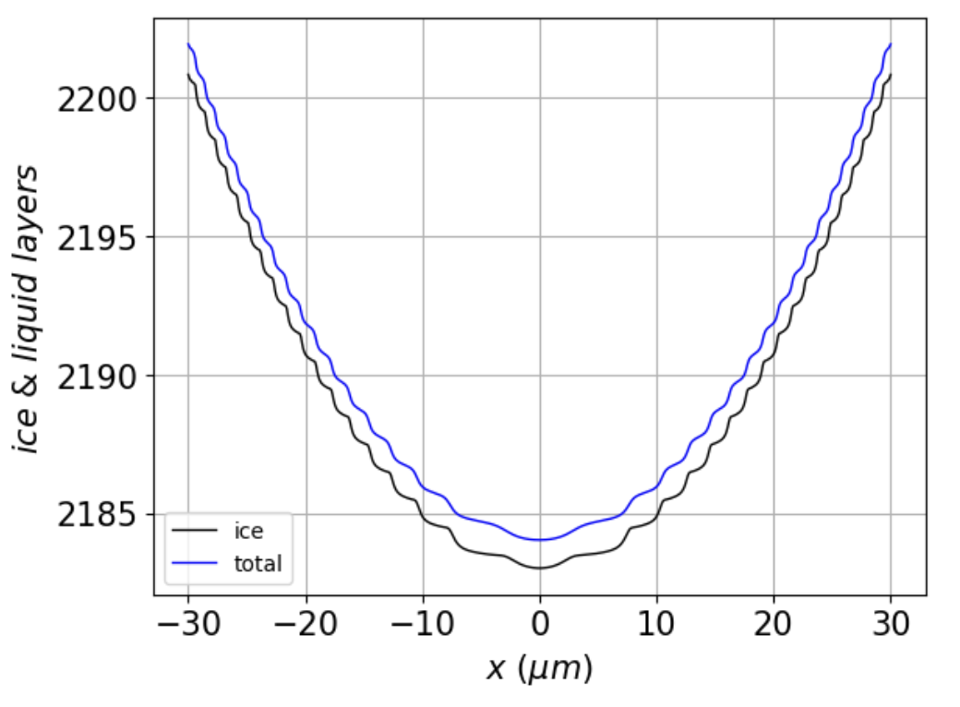 | 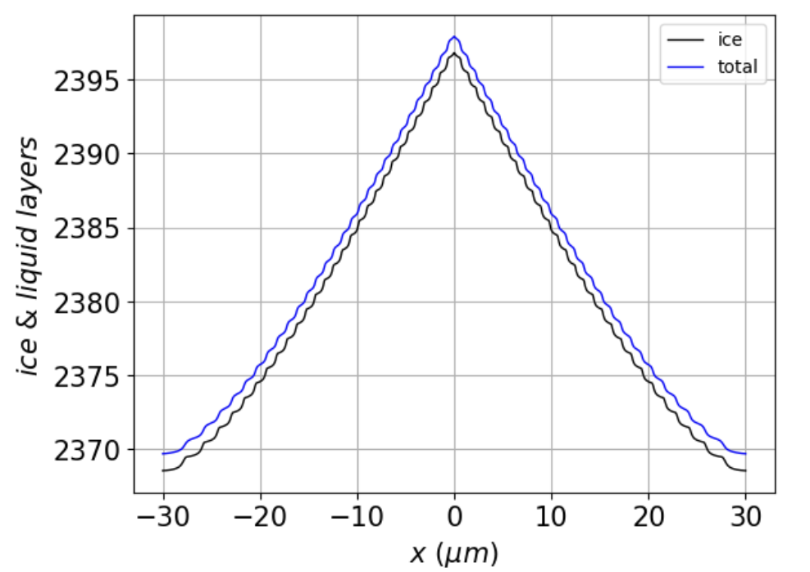 | 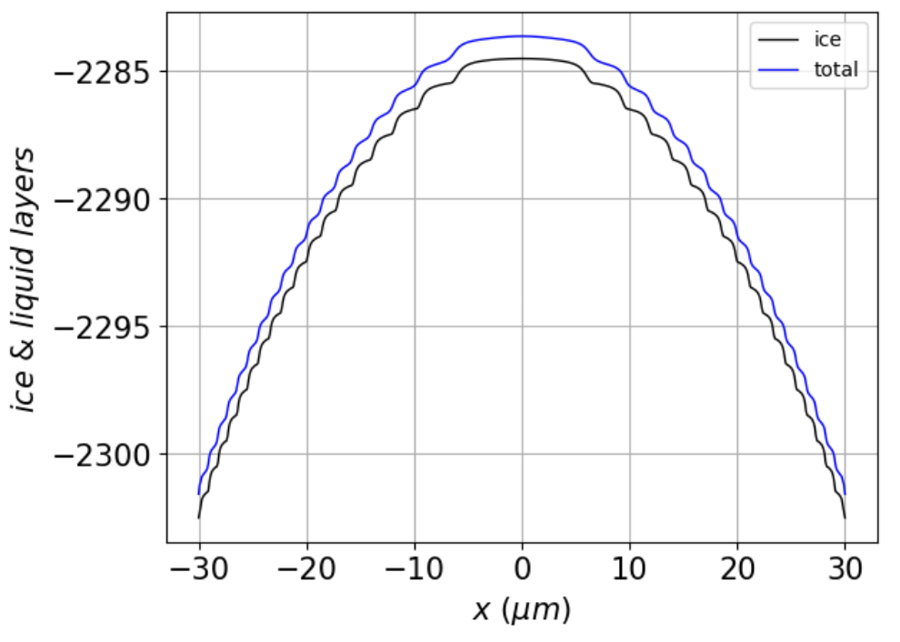
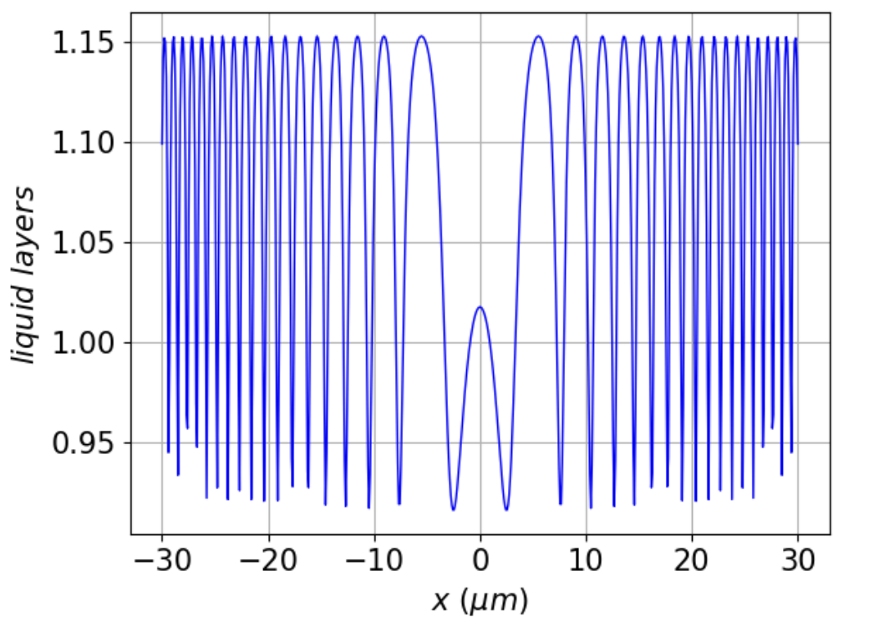 | 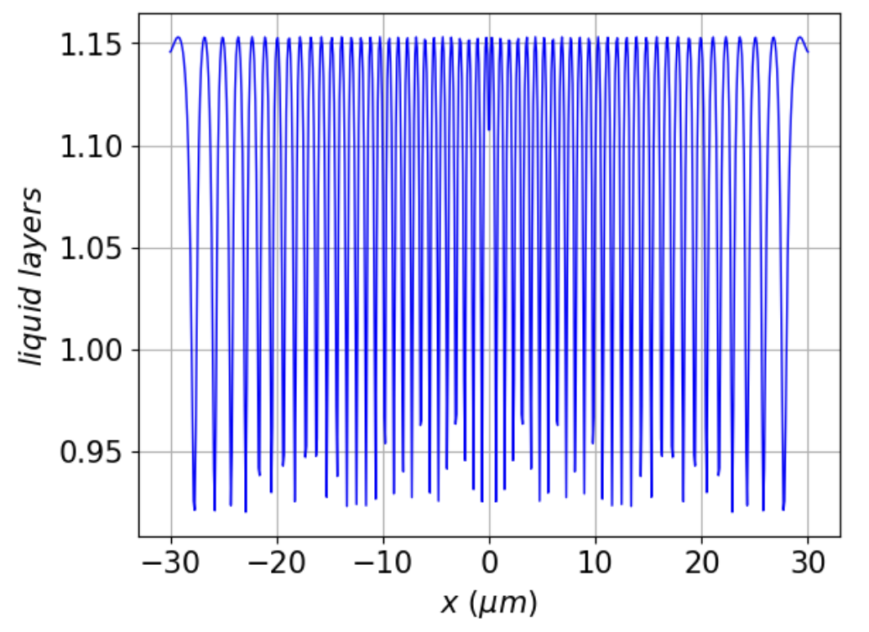 | 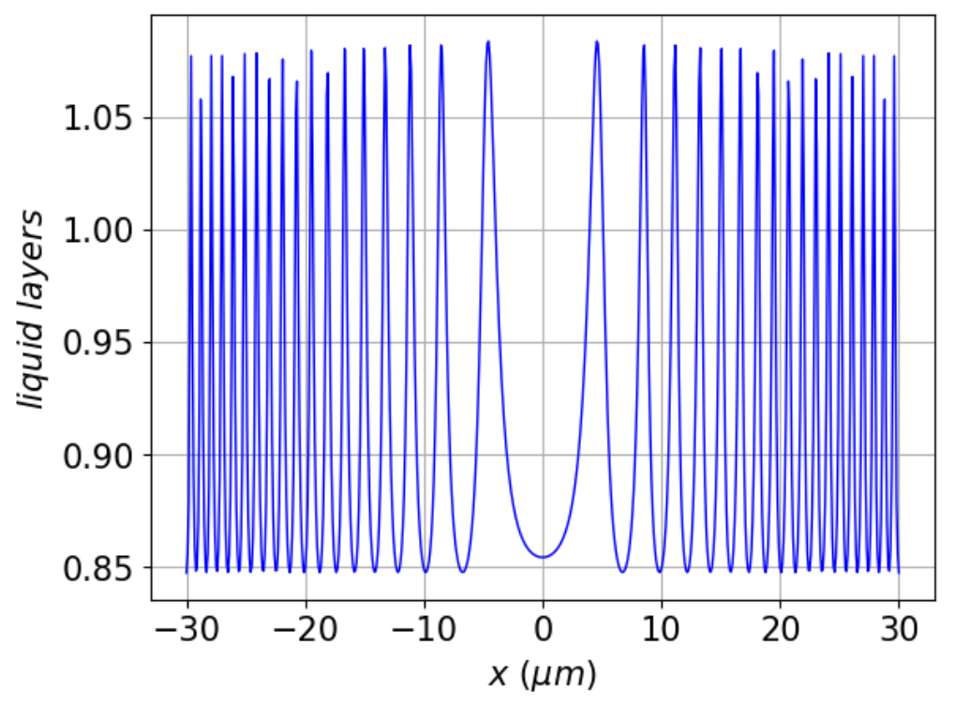
Figure 3. Simulations of baseline scenarios (see Table 1). Top row: vapor supersaturation profiles; Second row from top: time evolution of the number of steps from facet centers to facet corners, beginning with a flat surface. Third row: total surface ($N_{tot}$) and ice-only ($N_{ice}$) thickness of the ice surface at $100 ms$ simulation time; Bottom row: $N_{QLL}$ (i.e., $N_{tot}-N_{ice}$) at $100 ms$ simulation time.

Next, we investigate the resilience of steady-state solutions to time-dependent perturbations in the vapor field. The sequence of images in Fig. 4 begins with an initially-flat profile, which is then subjected to the following sequence:

- From $0$ to $400 ms$, the surface is been exposed to the supersaturated water vapor curve shown in the inset located in the upper right part of the figure. By $400 ms$, the profile has evolved to the faceted, steady-state profile labeled “A”.
- From $400$ to $800 ms$, a perturbation is introduced in the form of the subsaturated water vapor curve shown in the inset located in the middle-right part of the figure. During this time, the surface evolves into the highly perturbed state labeled “B”.
- From $800$ to $1200 ms$, the initial supersaturated water vapor regime is restored. During this time, the surface recovers its pre-perturbation faceted profile labeled “C”.

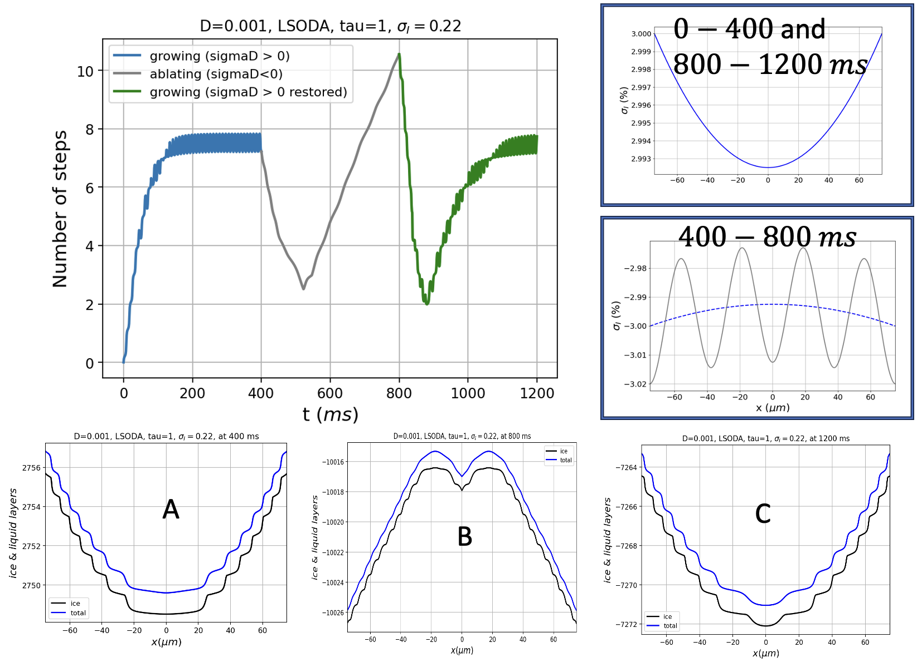
Figure 4. Examination of model facet resilience. Curves in the upper-left graph show timelines of $n_{steps}$ that characterize the surface when subjected to the supersaturation curves shown in the upper-right insets, over the indicated time intervals.

Finally, we examine properties of limit cycles/traveling waves. A useful metric for describing the curvature of profiles such as those appearing in Fig. 5 is the mean horizontal distance between successive molecular layers, defined as

${\overline{λ}}_{QLC2}=L/n_{steps}$ (12)

Figure 5. Mean horizontal layer separation, $\overline{λ}$, as a function of $D_{QLL}$ … | 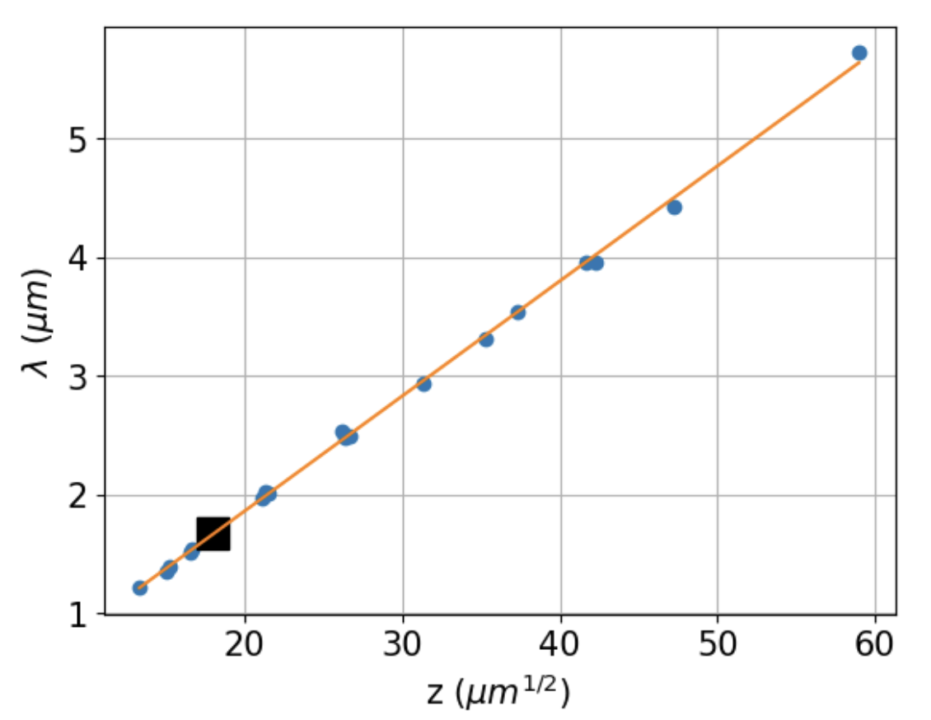

Conclusion … ${\overline{λ}}_{QLC2}∝D^{\frac{1}{2}}$. Thus, we see that a key characteristic length predicted by QLC-2 depends on the square root of the surface diffusivity. This dependence is hallmark of Turing’s analysis of instability of reaction-diffusion systems leading to pattern formation. However, it should be borne in mind that the patterns of QLC-2 “steady states” are actually traveling-wave limit cycles, which are not considered in Turing’s analysis. Any such connection must overcome another hurdle as well, namely, that the depths of these characteristic distances are vastly different in QLC-2 compared to experiment: in the former it is a few monolayers, while in the latter it is thousands of monolayers.

In terms of facet resilience, we have seen that QLC-2 solutions and SEM-grown ice crystals both exhibit a propensity for perturbed states to recover when conditions favorable to faceting are restored.

- Summary and discussion
The QLC-2 model presented here offers significant technical improvements over the QLC-1 model reported in N2016, in that its equations of motion embody a more faithful representation of ice/QLL freeze/melt equilibration, as indicated by Molecular Dynamics simulations. That connection, in turn, enables the theory to represent a more unified picture of ice surface dynamics than has previously been possible. The model predicts facet convexity and concavity, a pattern that is echoed in reconstructions of SEM-grown ice crystals. The model also provides a mechanism by which real ice crystals resist dendritic geometries when subjected to supersaturation conditions (i.e., faceted growth), and how they also resist rounding when subjected to subsaturation conditions (faceted ablation). It is, essentially, a theory of faceting that rests fundamentally on atomistic variations in the thickness and volatility of the quasi-liquid layer.

Qualitative implications of this work for cirrus cloud particles can be summarized as follows: As such particles fall through Earth’s atmosphere, such crystals will encounter increased pressure, hence smaller $D_{vap}$, but also increased temperatures (unless there is an atmospheric inversion), hence larger $D_{vap}$. When the effect of increased pressure dominates, QLC-2 predicts enhanced growth at facet corners, hence greater facet convexity, and therefore a greater propensity toward hollowed crystal structures. When the effect of increased temperature dominates, however, we can expect more regular hexagonal shapes. Although there is no single observational datum that would help us resolve these predictions, we can comment that in exceptionally cold regions (such as the Antarctic Plateau), or even in mid-latitudes where high-altitude cryo-capture of ice crystals on ground-launched balloons is possible, observations have shown that cirrus clouds are frequently hollowed, suggesting dominance of increased pressure distinctive (Magee et al. 2014, 2021; Walden, Warren, and Tuttle 2003).

We should note that the results presented here do not consider variations in parameters $σ^{o}$, $N^{*}$ and $\overline{N}$, because these values are highly uncertain; more detailed molecular dynamics calculations could provide plausible values, but those studies have not been reported. We can speculate that because different facet types (basal, prismatic, or pyramidal) have distinct underlying crystal cell structures, their quasi-liquid properties will also be Exploratory numerical studies varying the thickness of a single “layer” of ice has shown that a proportional increase in $\overline{λ}$ results. Preliminary numerical experiments varying $N^{*}$ and $\overline{N}$ have shown that …

A separate speculation concerns the observation that the $D^{1/2 }$ dependence of $\overline{λ}$ values exhibited by QLC-2 is the same as in Turing patterns. In one sense this should come as no surprise, since Turing’s theory, like QLC-2, is based on a reaction-diffusion equation. But there are also very big differences, including the fact that Turing’s analysis proceeds from an analysis of sensitivity to perturbations to an initially homogeneous distribution of chemical species, whereas the patterns in QLC-2 emerge as steady states of the equations of motion. The work of (Arioli and Koch 2015), on traveling-wave solutions of reaction-diffusion equations, is relevant here.

Finally, we note that the atoms-to-mesoscale approach represented in QLC-2 is not as fully integrated as we would like it to be … maybe some insight from Jake’s heterogeneous multiscale approach is the way forward on this (Shohet et al. 2020).

Appendix 1 – QLC-1 explanation of faceted growth
The main insight afforded by QLC-1 is that it provides a mechanism by which faceted ice crystal growth can occur, summarized as follows (the reader is referred to N2016 for a more complete and quantitative version of these arguments).

- Designating the horizontal distance between new layers and their predecessors as “$λ$” (see Fig. 2), we see that $λ_{corner}<λ_{center}$; this is because new layers typically form at facet corners, where the water vapor concentration is highest, as described above.
- Horizontal diffusion moves quasi-liquid away from $μ$surface II regions of the surface, toward $μ$surface I regions, because the former is thicker than the latter. The result is an overall increase in the average volatility of the surface, causing the surface as a whole to experience a net “diffusive slowdown” in its growth rate.
- In regions where $λ$ is small, QLL thickness gradients are large. In Fig. 2(b), for example, it is clear that the gradient in QLL thickness at I’ is greater than at I. It follows that, in a growing ice crystal, more diffusive slowdown occurs at facet corners.

In summary, a flat facet exposed to supersaturated vapor will initially experience higher growth rates at its corners, because of higher vapor concentration there, which leads to a higher step density (smaller $λ$) there, hence a reduction in the growth rate at corners relative to facet centers. When these effects become balanced – which can (and does) occur as an emergent property of the equations of motion defining QLC-1 (and QLC-2, as we will show here), the result is equal growth rates across the entire facet. The resulting traveling wave would be interpreted at the mesoscale (e.g., in a high-resolution optical or scanning electron microscopy experiments) as faceted growth.

Appendix 3 – Vapor field calculations

Table A3.1. Parameters for simulation of the vapor field around a growing, square-shaped ice crystal
Simulation space dimensions | $$X=Y=±500 μm$$
Time step for integration | $$dt=5×{10}^{-5} μs$$
Time interval for integration | $$t_{max} =2 μs$$
Spatial discretization | $$dx=dy=2.8 μm$$
Diffusion coefficient at $T_{amb}=273 K$, $P_{amb}=1 atm$ | $$D_{vap}^{o}=21.9 μm^{2}/μs$$
Ambient temperature | $$T_{amb}=240 K$$
Ambient pressure | $$P_{amb}=68.6 Pa$$
Diffusion Temperature-correction exponent | $$m_{D}=1.86$$
Diffusion coefficient under ambient conditions | $$D_{vap}=3.49 ×{10}^{4} μm^{2}/μs$$
Far-field water vapor partial pressure | $$P_{vap,f}=30 Pa$$
Far-field water vapor supersaturation | $$x_{f}=1000 μm$$
Far-field distance from the origin | $$σ_{I}=0.25$$
Mass density of ice | $$d_{ice}=0.9 g/cm^{2}$$
Growth rate of ice surface | $$g_{ice,s}=2 μm/s$$

References:
Anon. n.d. “Air - Diffusion Coefficients of Gases in Excess of Air.” Retrieved February 4, 2024 (https://www.engineeringtoolbox.com/air-diffusion-coefficient-gas-mixture-temperature-d_2010.html).
Arioli, Gianni, and Hans Koch. 2015. “Existence and Stability of Traveling Pulse Solutions of the FitzHugh–Nagumo Equation.” Nonlinear Analysis: Theory, Methods & Applications 113:51–70. doi: 10.1016/j.na.2014.09.023.
Benet, Jorge, Pablo Llombart, Eduardo Sanz, and Luis G. MacDowell. 2019. “Structure and Fluctuations of the Premelted Liquid Film of Ice at the Triple Point.” Molecular Physics 117(20):2846–64. doi: 10.1080/00268976.2019.1583388.
Berg, W. F. 1938. “Crystal Growth from Solutions.” Proceedings of the Royal Society of London. Series A - Mathematical and Physical Sciences 164(916):79–95. doi: 10.1098/rspa.1938.0006.
Di Prinzio, Carlos Leonardo, Damian Stoler Flores, Guillermo Gabriel Aguirre Varela, and Esteban Druetta. 2020. “Superficial Self-Diffusion Coefficient in Ih-ICE.” doi: 10.5817/CPR2020-2-12.
Harrington, Jerry Y., and Gwenore F. Pokrifka. 2021. “Approximate Models for Lateral Growth on Ice Crystal Surfaces during Vapor Depositional Growth.” Journal of the Atmospheric Sciences 78(3):967–81. doi: 10.1175/JAS-D-20-0228.1.
Järvinen, Emma, Bastiaan van Diedenhoven, Nathan Magee, Steven Neshyba, Martin Schnaiter, Guanglang Xu, Olivier Jourdan, David Delene, Fritz Waitz, Simone Lolli, and Seiji Kato. 2023. “Ice Crystal Complexity and Link to the Cirrus Cloud Radiative Effect.” Pp. 47–85 in Clouds and Their Climatic Impacts. American Geophysical Union (AGU).
Jayaprakash, C., W. F. Saam, and S. Teitel. 1983. “Roughening and Facet Formation in Crystals.” Physical Review Letters 50(25):2017–20. doi: 10.1103/PhysRevLett.50.2017.
Kuroda, T., and R. Lacmann. 1982. “Growth Kinetics of Ice from the Vapour Phase and Its Growth Forms.” Journal of Crystal Growth 56(1):189–205. doi: 10.1016/0022-0248(82)90028-8.
Llombart, Pablo, E. Noya, and Luis MacDowell. 2020. “Surface Phase Transitions and Crystal Habits of Ice in the Atmosphere.” Science Advances 6:eaay9322. doi: 10.1126/sciadv.aay9322.
Magee, N. B., A. Miller, M. Amaral, and A. Cumiskey. 2014. “Mesoscopic Surface Roughness of Ice Crystals Pervasive across a Wide Range of Ice Crystal Conditions.” Atmospheric Chemistry and Physics 14(22):12357–71. doi: 10.5194/acp-14-12357-2014.
Magee, Nathan, Katie Boaggio, Samantha Staskiewicz, Aaron Lynn, Xuanyi Zhao, Nicholas Tusay, Terance Schuh, Manisha Bandamede, Lucas Bancroft, David Connelly, Kevin Hurler, Bryan Miner, and Elissa Khoudary. 2021. “Captured Cirrus Ice Particles in High Definition.” Atmospheric Chemistry and Physics 21(9):7171–85. doi: 10.5194/acp-21-7171-2021.
Murata, Ken-ichiro, Ken Nagashima, and Gen Sazaki. 2019. “How Do Ice Crystals Grow inside Quasiliquid Layers?” Physical Review Letters 122(2):026102. doi: 10.1103/PhysRevLett.122.026102.
Neshyba, Steven, Jonathan Adams, Kelsey Reed, Penny M. Rowe, and Ivan Gladich. 2016. “A Quasi-Liquid Mediated Continuum Model of Faceted Ice Dynamics.” Journal of Geophysical Research: Atmospheres 121(23):14,035-14,055. doi: https://doi.org/10.1002/2016JD025458.
Neshyba, Steven, Erin Nugent, Martina Roeselová, and Pavel Jungwirth. 2009. “Molecular Dynamics Study of Ice−Vapor Interactions via the Quasi-Liquid Layer.” The Journal of Physical Chemistry C 113(11):4597–4604. doi: 10.1021/jp810589a.
Price, William S., Hiroyuki Ide, and Yoji Arata. 1999. “Self-Diffusion of Supercooled Water to 238 K Using PGSE NMR Diffusion Measurements.” The Journal of Physical Chemistry A 103(4):448–50. doi: 10.1021/jp9839044.
Shohet, Gil, Jacob Price, Jeffrey Haack, Mathieu Marciante, and Michael S. Murillo. 2020. “Heterogeneous Multiscale Method for High Energy-Density Matter: Connecting Kinetic Theory and Molecular Dynamics.” Journal of Computational Physics: X 8:100070. doi: 10.1016/j.jcpx.2020.100070.
Walden, Von P., Stephen G. Warren, and Elizabeth Tuttle. 2003. “Atmospheric Ice Crystals over the Antarctic Plateau in Winter.” Journal of Applied Meteorology and Climatology 42(10):1391–1405. doi: 10.1175/1520-0450(2003)042<1391:AICOTA>2.0.CO;2.

